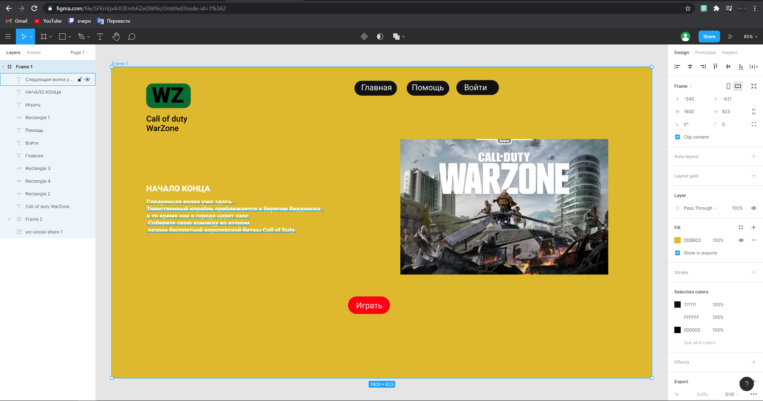

https://www.figma.com/file/SFKnVjx4rX3EmhAZeOWl6s/Untitled?node-id=1%3A2